Smith Center Evangelical Free Church:
Vacation Bible School * 2019 Family Pre-Registration Form

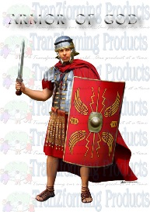
“Prepare for Battle”

EFC VBS will provide supplies, lunch and a T-shirt.
For free Tshirt & supplies register by July 8, 2019
Bring or mail registration form to: Evangelical Free Church, 1107 N. Main (PO Box 143), Smith Center, KS 66967
Contact: Karen Bischoping; Phone: 785-697-2760; Text Message: 785 476-8087; email: karenbischoping@hotmail.com

Wednesday, July 24, 2019 9:00 AM – 3:30 PM and Thursday, July 25, 2019 9:00 AM – 3:30 PM
Evangelical Free Church - 1107 N. Main - Smith Center, Kansas
(Age or grade as of May 2019) Group 1: 4 years old thru 1st grade Group 2: 2nd grade thru 6th grade
Parent/Guardian Name: | Registration Date:
Address:
City:
Best way to contact:
Phone numbers:
Email address:
Comments:

Child's Name | Age/Grade |  | Boy/Girl |  | T-shirt size |  | Allergies/Restrictions

Parent or Guardian: ____________________________________________ Date: ______________

EFC VBS 2019

“Prepare for Battle”

Please pre-register by July 8, 2019

Dates: July 24 – 25, 2019
Time: 9:00 AM – 3:30 PM
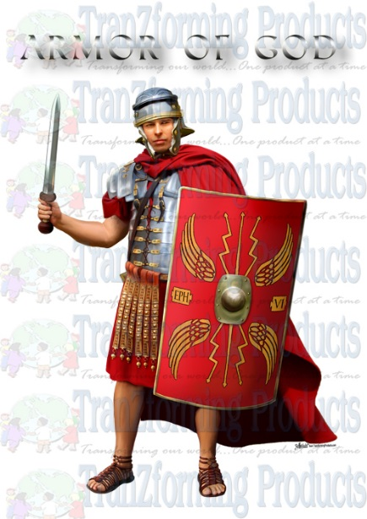

Grp 1 = 4 yrs - 1st grade

Grp 2 = 2nd - 6th grades
Age and grades as of May 2019
EFC VBS will provide supplies, lunch and a T-shirt.

Questions: Karen Bischoping
Home Phone-785 697-2760; Test Msg-785 476-8087

